Online School Portal
https://students.ashworthcollege.edu/dashboard
Username: Carriegilles@ymail.com
Password: 133Pinson

Sign in
Click on English 4: Part 2 General Program
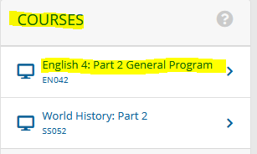

Click on Assessments
- Assignments
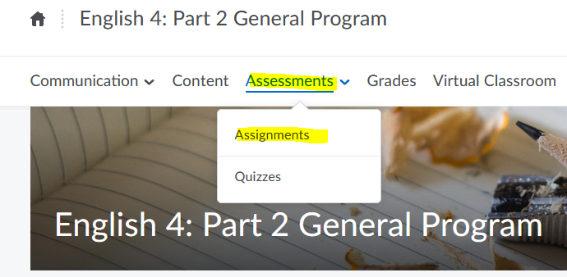

Lesson 4 Shakespeare Argument or Creative Character Analysis
Prompt 1:—Shakespeare Essay/Does Shakespeare Still Matter?
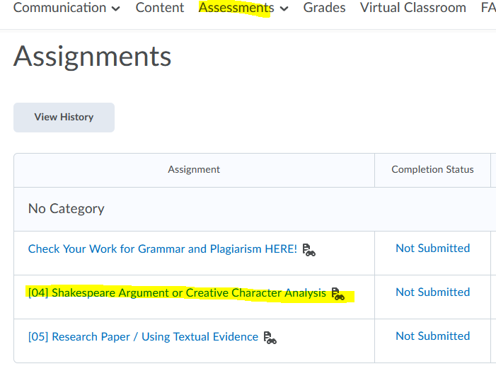
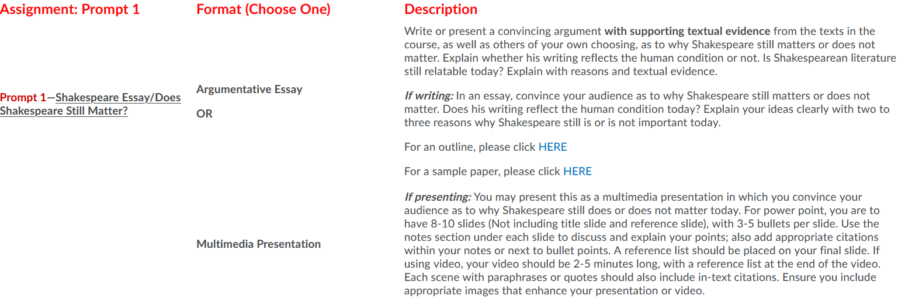

For all information needed on this Essay, it can be found on the portal
Under the Content tab
